Tour To Bromo Mountain

Welcome to Bromo Tour Packages. We Are Specialist Travel Services Bromo Tour Packages. Experienced, Professional & has been trusted by various Government Agencies and Private.

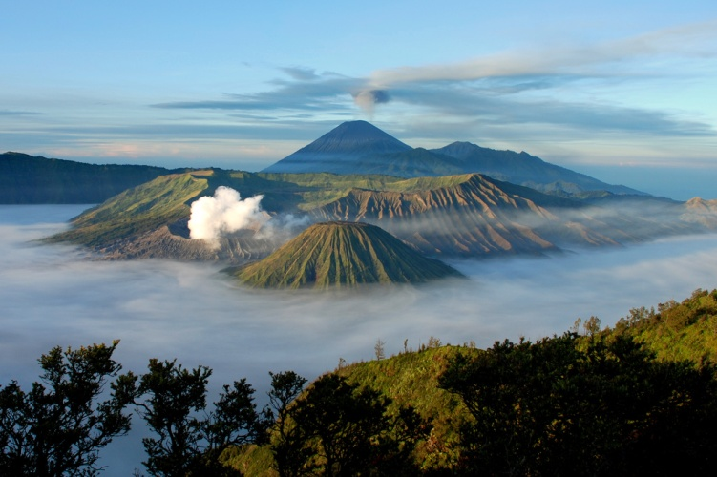

Journey through the west door of the direction of Pasuruan is entering the village Tosari to go to the center of the tourist attraction (sea of ​​sand) We are here to help you get your money around the world. But if we go to the front door, we are going to go to the village of Tonga, we will go to the village of Cemoro Lawang before going to the sea of ​​sand then it is not too heavy Because the derivative of the slope is not so steep that any motorcycle can pass through.Most tourists who want to easily reach the sea of ​​sand through this path. But if you want to watch the sun is often displayed in the photographs, which many photographed from the peak of the climb then you are more practical pass the western door.   
  
But if you have an adventurous spirit then you are traveling by tourists. That is through the city of Malang you enter through a small town overlay then enter the city pronojiwo ago going through a very beautiful nature reserve a fork in the road to the south of the country (towards the mountain semeru and towards the north of bromo mountain. The fork is named Jemplang.The journey begins with a downfall that is then greeted with grasslands. This road will be round the mountain for 3 hours. This line is actually not too steep and can be passed by a motorcycle, but requires an adventurous spirit because the path is still rarely passed and there is no single stopover or home resident. We will truly be presented with a very challenging journey. But you will be rewarded with another Bromo secret, which is very rare, the savanna and botanical wilderness is very wide behind **Mount Bromo**. It was an opposite sight on its barren and dusty northern side.But keep in mind, you should not go through this path. The path will not be visible in a condo like this.   
  
Sea of ​​sand is [**the mainstay of Mount Bromo**](https://www.paketbromo.co.id/), in the cool mountainous realm, we can see the desert and the wide grass. While the most awaited of the mountain is sightview when the sun rises and sets because it will look very clear and very beautiful. Although the trip to Bromo is very dusty, but it does not feel, because the beauty that is presented is truly remarkable.   
  
Vacation to bromo is practically perfect if you like the traveler type and through the north doorway. You can visit within 12 hours. of course, Surabaya, Malang, Jember and surrounding areas.The journey can start from 12 pm so you will arrive around 2 - 3 am. Where can you rest before you see the sunrise. Food and beverage sellers in the area are usually open by 3 o'clock in the morning, so you can get ready to climb**the famous bromo peak** ladder. enjoy the view until 9 am and you can return to your departure city around 12 noon. For the record, if you travel in the darkness of the night, look at the parking area around the temple as you go to the temple. And if you get lost do not panic and continue the journey (especially in the thick fog), wait for it usually start at 2 - 3 am some outside the sea.

Contact Person:

[Facebook](https://www.facebook.com/bromo.susanto.9)

[Twitter](https://twitter.com/bromotour88)

[Google Plus](https://plus.google.com/u/0/104399249109684133834)

[E-mail](http://bromotourandtraveling@gmail.com/)

[​​​​​​​​​​​​​​Website](https://www.paketbromo.co.id/)